This project will take you back to childhood when you wove strips of construction paper to make a pretty but highly impractical ‘place mat’ for your mom. This time around, you will be working with fabrics to create a functional mat or a small wall hanging that can be stitched decoratively or embellished if you wish. The basic process will create two simple panels identical in pattern but with colors reversed in each. A slightly more complex approach will yield four panels, a perfect number to make a set of coordinating place mats for yourself or as a gift.

Please be courteous to others by arriving for class with the correct supplies. Contact me at 503-631-8806 or helene.m.knott@gmail.com if you have any questions.

A Note to Students: Many students do not realize that once the teacher is paid, the shop offering a class makes little if any income on the class itself. The shop is relying on product sales to continue offering quality classes to you. Therefore, I urge you to patronize this shop when buying your supplies for this class as much as possible and remind you that big chain stores do not offer the variety of classes that the smaller shops do. Keep quilt classes alive by supporting this shop.
Thank you, Helene

TOOLS/MATERIALS:
- Freezer paper: A couple of feet from an 18” roll will do, to draft the panel designs on.
- Drawing pencil and eraser: Bring a good white rubber/plastic eraser, do not rely on the one at the end of the pencil; they rough up the paper and wear down too quickly. A mechanical pencil with extra leads is preferable to one that needs constant sharpening.
- Sharpie® brand black marking pen: The fine-point not the ultra-fine works best.
- Fusible web: Buy one that has a paper foundation: Heat n’ Bond, Soft Fuse, Wonder Under… an adhesive web with one layer of base paper is preferable to the kind with two layers (Steam a Seam 2). Do not buy the type with no paper. You will need about 2 ¼ yards from a roll for four place mats (less for a wall hanging). Buy it from a roll. the individual sized sheets that come in a package are too small for anything than a very small page-sized panel.
- Scissors: Fabric scissors that you don’t mind using to cut adhesive/paper backed fabrics with
- Fabric: Two to four Fat Quarters in contrasting prints/colors. These can be quilters’ cottons but to fully explore textures, these should be four distinct fabric textures. Think ‘rough, ‘plush’, ‘satiny’, and ‘plain’. It’s fun to combine coarse linen, velvet or corduroy, satin/brocade, and a plain or textured cotton. You will have as many finished panels as you have fabrics.
- Thin cotton or poly batting or preshrunk flannel: The exact size/amount will depend on how many woven panels you plan to make and what size they will be. A ‘craft’ sized batting will be enough for four projects, but a layer of flannel is preferable for place mats. Make sure you preshrink your filling (other than Poly) if if you don’t want your place mats to shrink and distort after washing. The thinner the filling, the better.
- Backing:. You will also need a backing fabric for each panel you plan to make, 1 yard of fabric should be adequate for four place mats.
- Rotary cutter, mat and cutting ruler: Ideally, the ruler should be at least 18” long but can be any width you have on hand.
- Sewing Machine: Capable of zig zag or embroidery stitching, with the standard accessories and (preferably) an open toed zig zag/embroideryfoot.
- Foam Core board: This is optional but will prove useful for the weaving process; a piece about 14” x 20” would be ideal.
- Thread: 100% cotton in colors that will work for the decorative or zig zag stitching on your fabrics.
- Pins: Ordinary sewing pins.
- Thread snips
- Seam ripper: Never leave home without one.

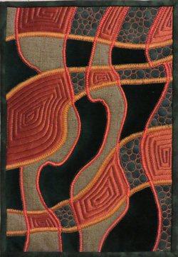Woven Textured Fabrics
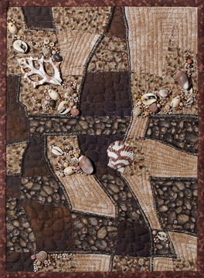Woven Cottons (Embellished)

