Come learn how to follow a Sweet Pea Pattern. We will learn to how to do a fake bias binding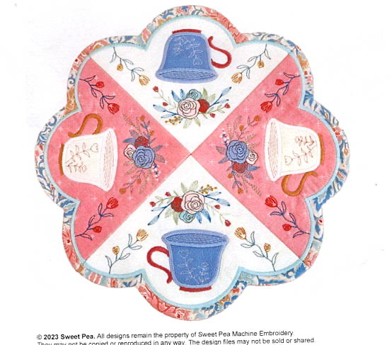 and to sew pieces together with a regular sewing stitch. Color choices are unlimited with this project. What a fun project to do to have on a table for tea time or anytime.

Class Supply list.

This class uses 3 pieces of fabric. Two for the background and 2 tea cups and 2 for then 2 More backgrounds and 2 more tea cup pieces. You will also need a piece for the binding.

We will make the 12 inch size in class so fabric amounts are listed below.

**Fabric A**: Background fabric>. 2 pieces cut 7.5 times 7.5 inches in color 1 and 2 pieces cut 7.5 times 7.5 inches in color 2.

**Fabric B:** Border Fabric: 4 pieces cut in 3.5 times 10.5 pieces

**Fabric C:**  Tea cups. 4 piece es cut 3.5 times 3.5 inches

**Fabric D:** 2 pieces cut 9 inches by 16 inches for your backing

Batting cut into 4 pieces 9 inches by 9 inches.

You will also need threads of your choice and your usual machine embroidery sewing supplies.

Type to enter text

This is a free pattern from Sweet Pea Designs.