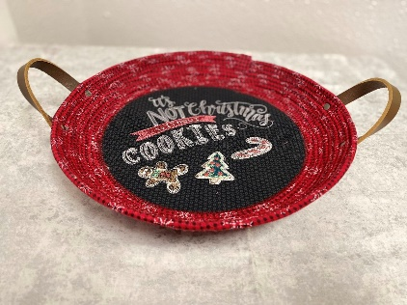**Rope Tray Supply List**

2- 12 x 12 fabric pieces for base

1 -12 x 12 OESD Ultra Clean and Tear Plus

1- 12 x 12 OESD Applique Fuse and Fix

* *If hoop size is smaller than 9.5 x 9.5 adjust fabric and OESD products accordingly*

1/3 yd fabric for bowl sides cut into 1 1/4” strips selvage to selvage

75 feet cotton rope(clothesline) with a solid core.

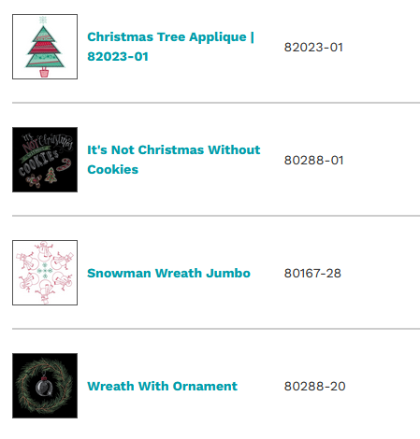Thread and bobbins to match base and bowl side fabric

40 wt Embroidery machine w/ thread colors for design

Embroidery hoop 9.5x9.5 recommended; smaller sizes will work *just note that bowl will be smaller.*

Sewing machine if your embroidery machine is not dual purpose/

Clear or open toe foot

Piping foot

Denim 90/14 needle

Embroidery designs no bigger than 7” x 7” with a stitch count no greater than 17,000 stitches

*Adjust design size if using a smaller hoop.*

*We will do some minor modifications on your design if your machine has design software installed, if not I can adjust designs in FTCU in class.

I have used the patterns shown purchased through the [OESD link](https://embroideryonline.com/?aff=321627) on the [Montavilla Sewing Center Website](https://embroideryonline.com/?aff=321627).

Alligator plastic clips

Pinking shears

Fabric glue and Glue stick

2- 6 ½ “long leather or cork ½” wide for handles

4 rivets to attach straps

***I will have handle kits for sale in class for $4 a set.***

Day 1 We will be making the embroidery design.

Day 2 Assembling the tray.

Remember you get 15% off all supplies for class at Montavilla stores!