A ‘totem’ is a symbol, usually an animal, which serves as an emblem of an individual or group of people to remind them of their ancestry or heritage. Often this belief is accompanied by a legend or myth. In tribal mythology, every animal has certain personality traits and a totem may be chosen from a desire to absorb that character - be it strength, cunning or wisdom. In this class, you will choose a totem from several designs that will be available, and make your own Spirit Totem quilt. The process of making this project is similar to making a Mola (Central American reverse appliqué) but incorporates Seminole strip piecing or foundation piecing for the body of the image. To make the process fast and easy, the project will be fused but those preferring another method of applique, are welcome to do so.

Please be courteous to others by arriving for class with the correct supplies. Contact me at 503-631-8806 or helene.m.knott@gmail.com if you have any questions.

A Note to Students: Many students do not realize that once the teacher is paid, the shop offering a class makes little if any income on the class itself. The shop is relying on product sales to continue offering quality classes to you. Therefore, I urge you to patronize this shop when buying your supplies for this class as much as possible and remind you that big chain stores do not offer the variety of classes that the smaller shops do. Keep quilt classes alive by supporting this shop.
Thank you, Helene

TOOLS/MATERIALS:
- Fabric: You can choose any colors you wish but keep value in mind. You need a distinct contrast between the Seminole insert, the outline and the background panel. My philosophy is to bring more fabric than you will actually use, this will give you the opportunity to fine-tune your choices.
- Animal Silhouette(s): Solids or fabrics that ‘read’ as solid will work best for the basic silhouette (you can make just the primary silhouette or frame it with a secondary outline if you wish). Fat Quarters will be sufficient.
- Background Panel: Choose a print that compliments your other fabrics. For a tribal or primitive look choose a graphic ethnic print but make sure it does not upstage your totem; a Fat Quarter will be adequate but ½ yard will give you more options for the size of your finished project. NOTE: You may need more fabric if you plan to incorporate your totem into a tote bag or garment.
- Seminole/Strip-piecing Fabrics: These can be scraps left over from other projects (for foundation or strip-piecing) or quarter yard/fat quarter cuts for Seminole piecing. You will need an assortment of colors, at least 5 or more. If you do not wish to make your insert from foundation or Seminole piecing you can choose a very bold vivid print for your insert.
- Borders: You will most likely not get to the stage of adding borders in the class, however bringing some border fabric choices may be helpful to decide how you want to handle the borders later.
- Thread: 100% cotton in a variety of colors to match your fabrics.
- Sewing Machine: With a piecing foot, a zig zag foot, and a free-motion foot might be helpful as well. Don’t forget your power cord and foot pedal!
- Regular wooden pencil and eraser
- Rotary cutter, mat and ruler: to cut long strips for Seminole piecing.
- Craft style scissors with sharp blades
- Seam ripper
- Fusible web: I prefer one designated ‘Lite’, 1 yard from a roll should be sufficient.
- Golden Threads™ Quilter’s Tracing Paper: A 12” wide roll will be sufficient.
- Masking Tape: Blue painter’s tape.
- Sewing Pins
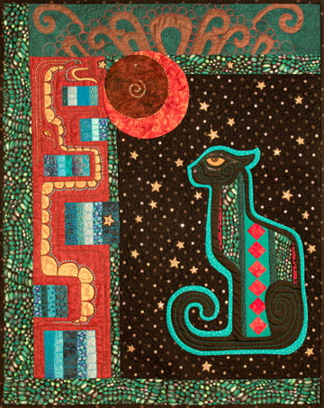
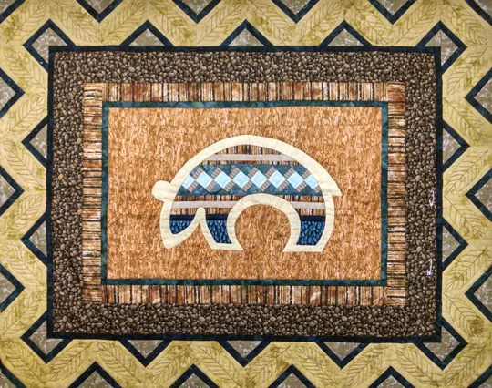
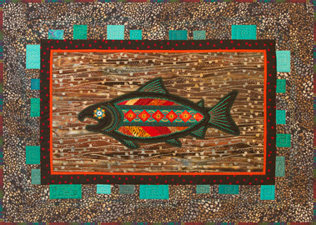
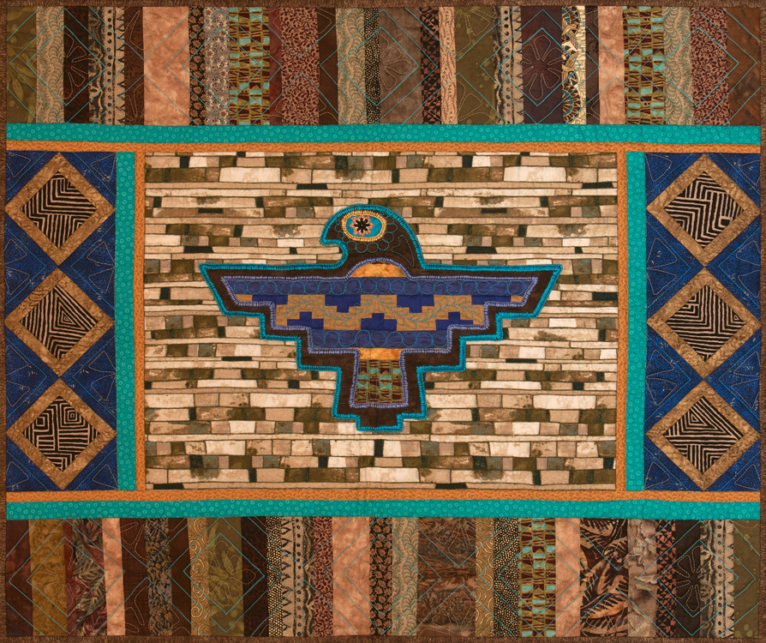
- Freezer paper: Available at supermarkets. There is an alternate raw-edged method to applique the totem silhouette that will minimize the stiffness from multiple layers of fusible web. Half a yard from a roll will be sufficient if you want to try this method.
- Teflon® Appliqué Pressing Sheet: To protect the iron and board; you can also use baking parchment or release paper.
- Light Box: This will be necessary to trace your pattern in reverse onto the fusible web (unless you don’t mind having your finished quilt reversed from the pattern). There are alternate ways of reversing the pattern but a light box is the easiest.
- Decorative Threads and Embroidery Stabilizer: For decorative machine stitching if you wish to embellish by machine.
- Pattern: One pattern of choice supplied with the class, additional patterns available for purchase from instructor.

