Reversible Jelly Roll Door Bow Supply List

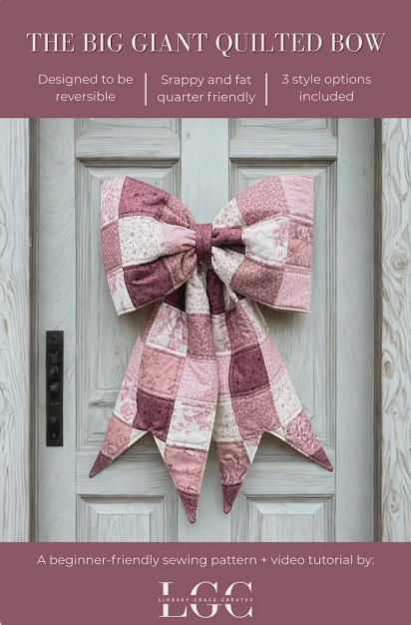
PATTERN: Montavilla will have these available in LO or for order from other stores.

 | DOUBLE SIDE JELLY ROLL BOW | JELLY ROLL + WHOLECLOTH BOW
FABRIC | SIDE A:  (13) 2.5” X 42” STRIPS  SIDE B:  (13) 2.5” x 42” STRIPS | SIDE A:  (13) 2.5” X 42” STRIPS  SIDE B:  1.5 YARDS
BATTING | 2 YARDS POLY FIL EXTRA LOFT | 2 YARDS POLY FIL EXTRA LOFT

Operational sewing machine
Coordinating cotton thread
3 pre-wound bobbins
Clips or Pins
Fabric marking pen or chalk
Scissors
Walking foot
80/12 needles
- If you have a portable iron and mat please bring it.
- All 2.5” fabric strips should be cut and ready to go for class.

