**Quilt As You Go Project Vinyl Bag**

This is a fun and easy project to make. You can use it to keep your sewing/quilting projects organized. With the vinyl front you are able to see what’s in the bag and the zippity-do-done zipper makes it easy to put together. The kit contains the pattern, zipper and vinyl to make two project bags; 16” and 18” square bags and enough vinyl to make two small zipper bags. You get to pick your own fabric. There are only 8 openings for this class. Class fee is $30.00. Kit fee: $25.00 to be paid to instructor on the day of class.

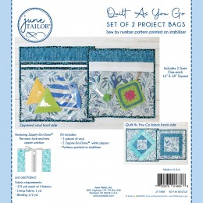

SUPPLIES NEEDED:

Bring sewing machine and accessories

Walking Foot

2/3 yards each of 4 fabrics

Lining Fabric: 1 yard

40 or 50 Wt Thread to match lining

Binding: ½ yard

40 or 50 Wt Thread to match binding

40” Trim to match fabric for each bag (optional)

Temporary Fabric Glue Stick

Straight Pins

Quilt clips

Frixion Marking Pen

2 ½” x 24 ½” Ruler

Rotary Cutter

80/12 or 90/14 No Stick Sewing Needles