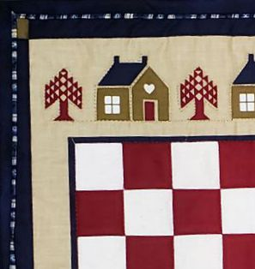
Quilt bindings are often applied in a combination of machine and hand stitching, a time consuming and labor intensive endeavor. Applying one completely by machine can be challenging to make a neat, precise binding. This method not only makes that final machine stitching a breeze but it looks quite attractive as well with a lovely precise accent piping.

Please be courteous to others by arriving for class with the correct supplies. Contact me at 503-631-8806 or helene.m.knott@gmail.com if you have any questions.

A Note to Students: Many students do not realize that once the teacher is paid, the shop offering a class makes little if any income on the class itself. The shop is relying on product sales to continue offering quality classes to you. Therefore, I urge you to patronize this shop when buying your supplies for this class as much as possible and remind you that big chain stores do not offer the variety of classes that the smaller shops do. Keep quilt classes alive by supporting this shop.
Thank you, Helene

Tools & Materials:
- Quilted project, ready to bind: Bring a quilt you would like to bind, or – if you don’t have one ready, you may bring a smaller project like a table runner or a simple pre-quilted panel to apply binding to. Your project should be quilted ahead of time, this class will not cover the quilting process. Trim and square your project, if you feel comfortable doing so ahead of time. If you are uncertain about how to trim the quilt properly, you may trim it in the class under the teacher’s guidance.
- Binding Fabric: the exact amount of fabric will vary depending on the size of the quilt and type of binding you choose to apply. ½ yard of each fabric, one color for the outer binding and a contrasting color for the piping, will be enough for a throw or twin sized quilt, ¾ yard will be needed for a queen/king sized quilt.
- Rotary cutter and mat
- Cutting rulers: You will need two rulers for the class – a 6” x 24” for cutting long strips, and a 4 ½” - 6” square ruler (with a 45 degree diagonal guideline).
- Scissors: A pair of craft scissors
- A quilters pencil in a color that will show up on the wrong side of your binding fabric
- Sewing pins
- 100% cotton thread: 50 wt. In a color that matches the piping fabric.
- Hand sewing needle: an applique ‘sharp’ in size 9 will be perfect
- Quilting/Binding clips (optional): Some quilters find these helpful while stitching.
- Stiletto: This can be helpful to hold binding in place while stitching.

