Mini Poppins Bag Supply List
Patterns with two stays included
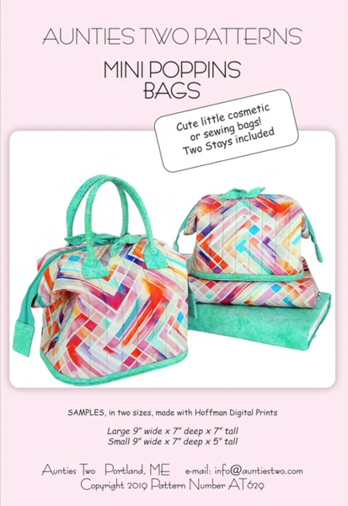

FABRIC
Large Small
Outside 3/8 yd ¼ yd
Bag body, Sashing

Inside
Bag Body lining, Sashing, Pockets 3/8 yd ¼ yd

Coordinating Fabric ½ yd ½ yd

Interfacing
Bag Body Bosal In R Form Plus 18” x 58” (double sided fusible foam interfacing)

Bottoms Craftex Plus 20” wide ½ yd
Zipper 24” or 30” Handbag zipper with double slides

Matching cotton thread
Sewing machine, walking foot, sewing machine needles Microtex 90/14, scissors, rotary cutter, clips, pins, chalk or frixion pen, seam ripper.

