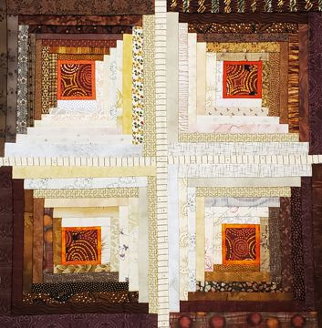
This block piecing technique, known domestically as Folded Log Cabin, is also sometimes called Manx Quilting because it is said to have originated on The Isle of Man where it is called a ‘Roof Block’. Once you start piecing, the similarity to laying roof shingles will become apparent. Strips of fabric are stitched, folded and layered to make a delightfully textured surface. To make this technique even better, you are quilting the block as you go so when you have you are done with a block, it can be finished into a mug rug, mat, or make a quantity of blocks to assemble into a finished quilt – no further quilting needed. This process will also be demonstrated in the class.

Please be courteous to others by arriving for class with the correct supplies. Contact me at 503-631-8806 or helene.m.knott@gmail.com if you have any questions.

A Note to Students: Many students do not realize that once the teacher is paid, the shop offering a class makes little if any income on the class itself. The shop is relying on product sales to continue offering quality classes to you. Therefore, I urge you to patronize this shop when buying your supplies for this class as much as possible and remind you that big chain stores do not offer the variety of classes that the smaller shops do. Keep quilt classes alive by supporting this shop.
Thank you, Helene

TOOLS/MATERIALS:
- Fabrics: You will need a dozen or more fabrics.
  - Selvedge to selvedge strips cut 1½” wide in a gradation of color, value and/or texture. The 1½” wide cut strips will be used to make your folded steps of the Log Cabin/Courthouse Steps, half of the fabrics should be light to medium and the other half, medium to dark; colors can be any that you wish but make sure you like them together.
  - An interesting novelty cut into 2” squares (or larger if you are featuring a motif print), you will need a center square for each block you wish to make.
  - You can opt to use a vivid narrow framing strip for the first row, this will be cut 1 ¼” wide and should contrast your center square. If you don’t want to cut your strips ahead of time and prefer to cut as you go, you can bring a dozen or more fat quarters.
  - Fabric for sashing strips for the final block assembly. The yardage will depend on how many and how large the blocks you are assembling will be but ½ yard will probably be adequate
- Piecing Foundation: The strips will be sewn directly on a foundation of batting and backing. You can make the final blocks any size you want, from 5” individual mug rugs with just a few strips, to larger blocks (8” - 12”) that you can assemble into a quilt. The larger the block, the more strips you will add. For each block, choose a thin even cotton batting cut 1” larger around the perimeter than you want your finished block to be and layered onto a backing that is just slightly larger than that.
- Cutting mat, cutting ruler and rotary cutter: A medium to large mat and 4” x 18” or larger ruler would be perfect.
- 1” x 6” ruler
- Chalk roller marking tool: With pink, yellow or blue chalk
- Sewing machine: With a ¼” piecing foot. NOTE: An open toe zig zag foot will be helpful for the final block assembly.
- Thread: 100% cotton in a medium neutral color
- Sewing pins
- Craft style scissors: To trim your strips after sewing.
- Thread snips
- Seam Ripper.

