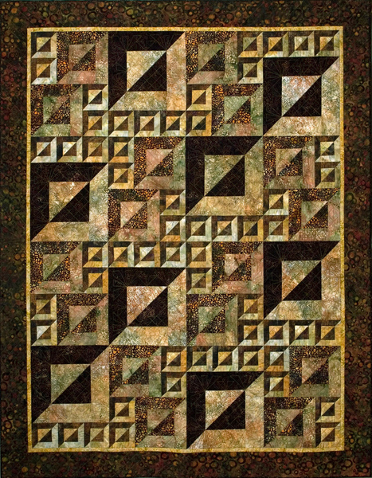
Magic Squares: With careful attention to color and value, this quilt will have a graphic architectural and three dimensional effects but is much easier to construct than most 3-D patterns. The name Magic Squares is a play on the name of a mathematical puzzle in which a grid of numbers adds up to an identical sum when added in any direction. This quilt constructed of repeated ‘units’ that create a random effect but go easily together without the use of partial seams. The quilt can be made larger or smaller with ease by adding or omitting units. There is a lot of cutting involved in making this quilt. You should cut at least some of the fabrics – enough to make a few sample 12” blocks in class but if you want to cut all the fabric ahead of time, it will make the construction of the quilt much faster. A cutting guide has been provided at the end of this list. Pattern will be provided in the class.
Please be courteous to others by arriving for class with the correct supplies. Contact me at 503-631-8806 or helene.m.knott@gmail.com if you have any questions.

A Note to Students: Many students do not realize that once the teacher is paid, the shop offering a class makes little if any income on the class itself. The shop is relying on product sales to continue offering quality classes to you. Therefore, I urge you to patronize this shop when buying your supplies for this class as much as possible and remind you that big chain stores do not offer the variety of classes that the smaller shops do. Keep quilt classes alive by supporting this shop.
Thank you, Helene

Fabrics: amounts given are somewhat generous to allow for shrinkage and straightening to grain. NOTE: if you wish to make a table runner half yard cuts of the fabrics will be more than enough.
Fabric | Throw Size | Twin Size | Table Runner
Fabric A (Dark)  12” blocks | ⅞ yard | 1⅛ yards | Fat Quarter
Fabric B (Light)  12” blocks | ⅞ yard | 1⅛ yards | Fat Quarter
Fabric C (Dark)  8” blocks | 1 yard | 1¼ yards | Fat Quarter
Fabric D (Light)  8” blocks | 1 yard | 1¼ yards | Fat Quarter
Fabric E (Dark)  4” blocks | 1 yard | 1 yard | Fat Quarter
Fabric F (Light)  4” blocks | 1 yard | 1 yard | Fat Quarter
Narrow Borders | ⅓ yard | ½ yard | ¼ yard (optional)
Wide Borders | 1 yard | 1⅛ yards | ½ yard (optional)

Tools/Materials:
- Sewing machine: With the basic accessories: extra needles, bobbins, etc.
- Thread: 100% cotton in a color to match your darker fabric.
- Rotary cutter, mat and ruler: a 24” cutting ruler and a large mat is the best for cutting the long strips and squaring your blocks. Make sure your cutter has a new sharp blade in it.
- 12½” squaring ruler: 12 ½” square ruler with a 45* diagonal guideline from corner to corner.
- Small pair of scissors or thread snips
- Seam ripper
- A mechanical pencil and a white quilters’ pencil (or a chalk roller)
- Sewing pins

Pre-cutting fabrics
Please pre-cut at least some fabrics before coming to class as this will save time and space. You may pre-cut all of your fabrics or only the amounts for the 12” blocks as we will start with those blocks. If you pre-cut all of your fabrics the quilt goes together fairly quickly.
For a table runner you will need:
One 12” block (optional)
From each fabric A and B cut:
One 7” square
One 3½” x 7” strip
Two 3½” x 10” strips
One 3½” x 13” strip

Four 8” blocks
From each fabric C and D cut:
Two 5” squares
Two 2½” x 5” strips
Four 2½” x 7” strips
Two 2½” x 9” strips
Fourteen 4” blocks
From each fabric E and F cut:
Seven 3” squares
Seven 1½” x 3” strips
Fourteen 1½” x 4” strips
Seven 1½” x 5” strips
For a ‘throw’ sized (48” x 64” w/o borders) quilt you will need:
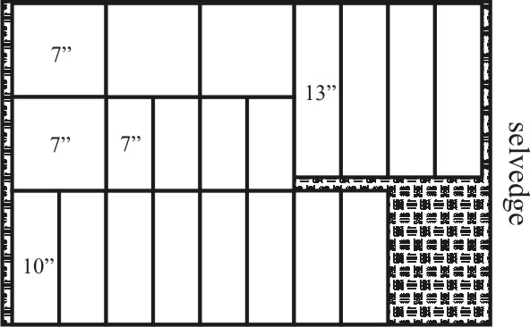
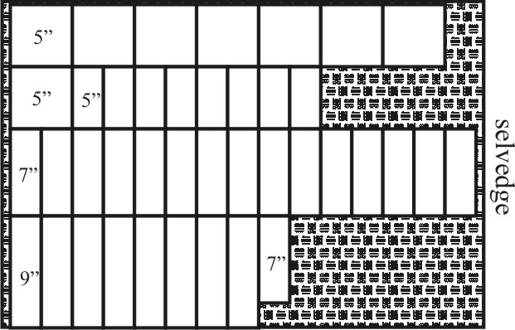
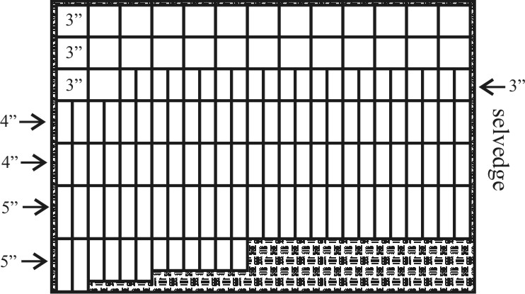
Eight 12” blocks
From each fabric A and B cut:
Four 7” squares
Four 3½” x 7” strips
Eight 3½” x 10” strips
Four 3½” x 13” strips

Sixteen 8” blocks
From each fabric C and D cut:
Eight 5” squares
Eight 2½” x 5” strips
Sixteen 2½” x 7” strips
Eight 2½” x 9” strips
Fifty-six 4” blocks
From each fabric E and F cut:
Twenty-eight 3” squares
Twenty-eight 1½” x 3” strips
Fifty-six 1½” x 4” strips
Twenty-eight 1½” x 5” strips
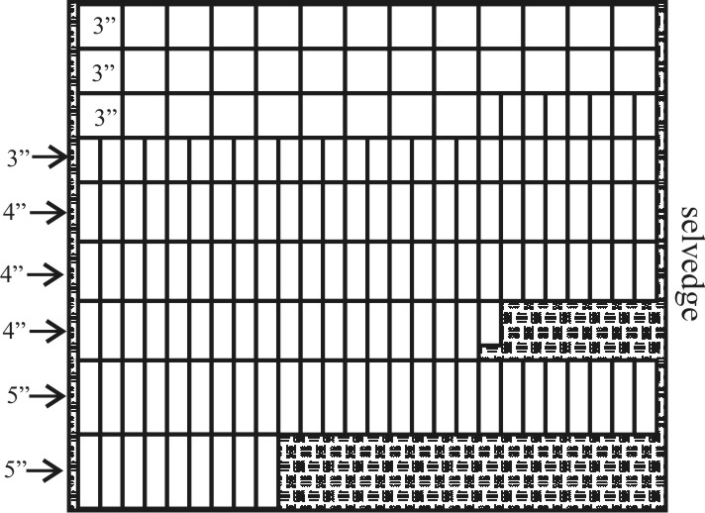
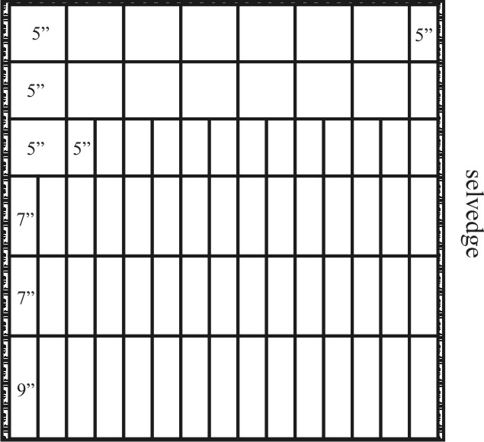
For a ‘twin’ sized (54” x 80” w/o borders) quilt you will need:
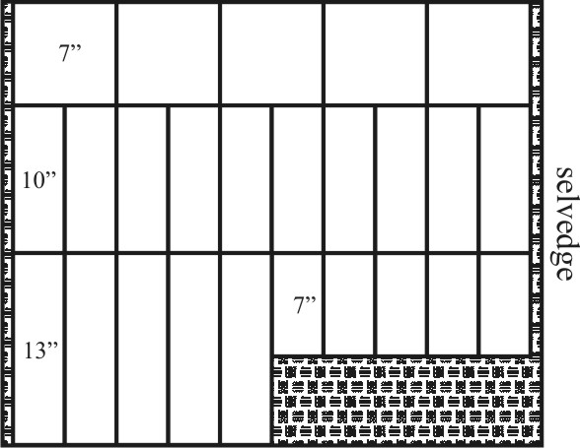
Ten 12” blocks
From each fabric A and B cut:
Five 7” squares
Five 3½” x 7” strips
Ten 3½” x 10” strips
Five 3½” x 13” strips

Thirty 8” blocks
From each fabric C and D cut:
Fifteen 5” squares
Fifteen 2½” x 5” strips
Thirty 2½” x 7” strips
Fifteen 2½” x 9” strips

Seventy 4” blocks
From each fabric E and F cut:
Thirty-five 3” squares
Thirty-five 1½” x 3” strips
Seventy 1½” x 4” strips
Thirty-five 1½” x 5” strips

