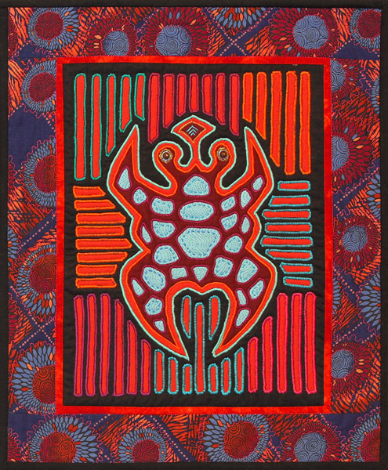
Molas are colorful reverse appliquéd folk art panels from Central America. Usually hand appliquéd with painstaking stitching; this fast and easy method uses machine appliqué and satin stitching to make these intricate panels a breeze. The resulting panel can be made into a wall hanging, a focal point for a larger quilt, a pillow or incorporated into a bag or garment.
NOTE: Though not necessary, basic free motion skills are helpful for this technique.

Please be courteous to others by arriving for class with the correct supplies. Contact me at 503-631-8806 or helene.m.knott@gmail.com if you have any questions.
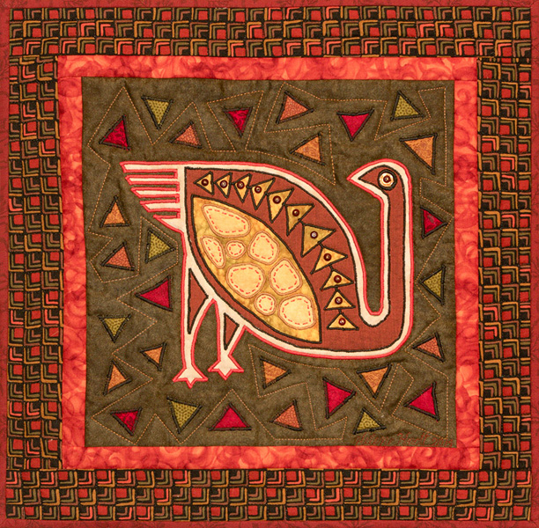
A Note to Students: Many students do not realize that once the teacher is paid, the shop offering a class makes little if any income on the class itself. The shop is relying on product sales to continue offering quality classes to you. Therefore, I urge you to patronize this shop when buying your supplies for this class as much as possible and remind you that big chain stores do not offer the variety of classes that the smaller shops do. Keep quilt classes alive by supporting this shop. Thank you, Helene

TOOLS/MATERIALS:
- Fabrics: You will need five or six 12” squares of fabrics that ‘read’ as a solid. They can be any colors you like (bright colors are traditional) that coordinate well but also and contrast with each other.
- Doodle cloth: this is a scrap of fabric layered with stabilizer or interfacing that is large enough for you to run zigzag stitching to test width and density before stitching on your project.
- Sewing machine: with a free-motion presser foot (absolutely necessary) and a zigzag/satin stitch foot. Make sure your machine is clean and in good working order. NOTE: for those not accustomed to free-motion sewing, a standard presser foot can be used but the process is much slower and exacting.
- Sewing machine needles: Machine quilting needles in sizes 11/75 and 14/90 or machine embroidery needles in sizes 12/80 and 14/90.
- Extra bobbins: you will be changing thread colors frequently so having at least 5-6 extra empty bobbins will give you more flexibility with you color choices.
- Embroidery scissors: To cut your reverse appliqué. These are absolutely necessary! Bring small-jawed, sharp pointed embroidery scissors like the stork scissors not regular sewing shears or appliqué scissors.
- Seam ripper: This tool is also absolutely necessary for this technique, make sure yours is sharp.
- Sewing pins
- Thread: You will need spools of 100% cotton thread in assorted bright solid (not variegated) colors; 4-5 colors will be adequate but a larger assortment will allow you to coordinate your colors better- the thread does not need to match fabrics but rather contrast with it so the exact colors is not important. You will also need a medium value neutral color (gray or taupe) OR invisible thread if your machine sews well with it.
- Pattern: There will be a variety of folk art patterns printed on water soluble stabilizer to choose from. One is included in the class price, additional patterns can be purchased by the sheet if desired.

