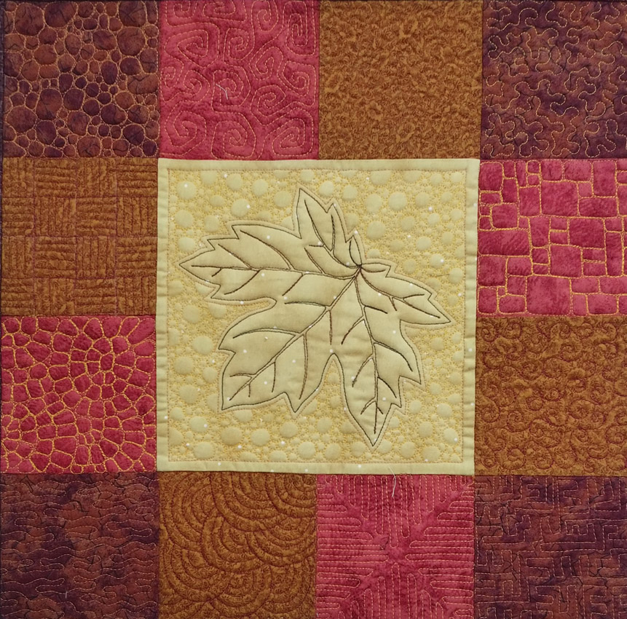
Allover textures are a key component in creating interesting quilting designs. Using textures and stitched framing can elevate pretty motif quilting to spectacular. Most quilters are familiar with the ubiquitous meandering ‘stipple’ (the one that looks like interlocking puzzle piece heads) and many quilters achieve this pattern skill and look no further at other possibilities. Don’t get stuck in a quilting rut! This class will help you explore lots of allover texture possibilities and show you how texture can be used to punch up other quilting designs. If you took the Machine Quilting Basics class, you can bring the sampler you made in that class to enhance with textural stitching, if not, you will make a pieced sampler as shown at the end of the supply list to bring and stitch on.

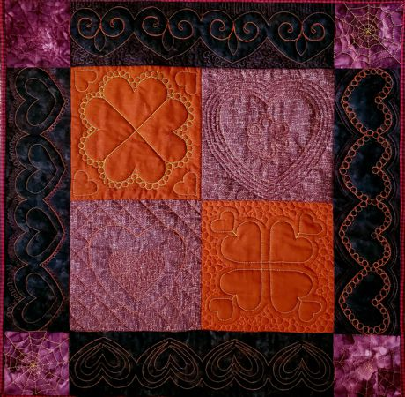
Please be courteous to others by arriving for class with the correct supplies. Contact me at 503-631-8806 or helene.m.knott@gmail.com if you have any questions.

A Note to Students: Many students do not realize that once the teacher is paid, the shop offering a class makes little if any income on the class itself. The shop is relying on product sales to continue offering quality classes to you. Therefore, I urge you to patronize this shop when buying your supplies for this class as much as possible and remind you that big chain stores do not offer the variety of classes that the smaller shops do. Keep quilt classes alive by supporting this shop.
Thank you, Helene

TOOLS/MATERIALS:
- Sewing Machine: A good basic home machine, preferably with feed dogs that can be dropped. A Singer Featherweight is not a good choice for machine quilting for a number of reasons. Please bring your owner’s manual if you have one and are not familiar with all the functions of your machine as well as the utility tools kit (small screwdrivers, brushes, etc) as you may need to perform some minor maintenance on your machine during class.
- Sewing Machine Accessories: You need to bring a free motion or darning/embroidery foot for free motion quilting (this is absolutely necessary). Make sure you have the right foot! I have seen a number of students come in with an open-toed embroidery foot which is intended for zigzag stitching and will not work for free-motion quilting! It’s also a good idea to fill and bring extra bobbins so you don’t have to interrupt your flow to wind bobbin thread.
- Sewing Machine Needles: Bring a package each of quilting and topstitching, needles in size 11 (or 12) and 14 suitable for your machine. Microtex ‘sharps’ in size 12 are optional but can be helpful.
- Pieced Top, Batting and Backing: See accompanying instructions for making your top. Use solids or textures that read as a solid to better see your stitches. The backing should measure 2” larger all around than the top. 1 yard of fabric will be sufficient for the backing. Please come to class with your top already pieced, layered & stitched in the ditch along the seams, we will not have the time to do this in class. NOTE: If you took my Machine Quilting Basics class, you can bring that project to enhance the basic motifs with textural stitching
- Stitching Test Square: This is simply a square about 14”x 14” of the same batting as your quilt, layered between two pieces of fabric. You will use this for practicing and to run a test for stitch length and tension before stitching on your quilt.
- Regular Straight Pins
- Thread: 100% cotton machine quilting thread. A variety of colors will allow you to pick and choose ones suitable for the designs you want to use.
- Drawing Pencil: with a good eraser
- Quilter’s marking pen: the blue rinse-away type.
- Utility Scissors: for cutting paper
- White Chalk marking pencil or roller You may or may not end up using this in class depending on the designs you choose to try but they will come in handy for future quilting projects. If using chalk, choose a color that will show up against your fabric (NOTE: colored chalk does not wash out of fabric very well if using while or very light fabric, use the blue pen instead)
- Thread snips
- Seam Ripper
- Paper: a few sheets of 8½” x 11” paper to do some practice doodling on.
- Machine Quilting Gloves (Optional): Help you grip the quilt more effectively and give you greater control of your stitching; my favorite brand is ‘Machingers’.
- Optional Book: 365 Free Motion Quilting Designs by Leah Day. NOTE: This book is not required but is recommended for reference designs

Machine Quilting Practice Sampler
For the best results, choose fabrics that read as solids; you do not want a print or pattern that is so pronounced that it interferes with your ability to see and critique your stitching.

For each texture sampler you will need:
Twelve 4 ½” squares of fabrics in various colors
One 8 ½” square of fabric in a contrasting color
One 18” square of thin even batting
One 20” square of backing fabric

Piece the 4 ½” squares into two strips consisting of two squares each and sew to each side of the
8 ½” center as shown. Press seams toward center. Sew remaining squares into two strips consisting of four squares each as shown. Press the seams to one side making sure the seams on each end of the 4-Square strips are pressed outwards. Sew the strips to the top and bottom of the center. Press these seams toward the center (this is important!). Layer and pin it with batting and backing, using safety pins spaced about 6” apart or spray baste if preferred, then quilt in the ditch along all seams. Make two of these layered and ditch quilted samplers. NOTE: color arrangement on the 4” squares can be random and scrappy or organized into a controlled arrangement if you wish.
Due to limited time and table space and the size of the classroom, you will need to have your quilts layered and stitched in the ditch before coming to class. The following directions will help you do this properly.
Choose a fabric for your quilt back that is the same weight or slightly heavier than your top. This will make your back more stable than the top and reduce the puckers and tucks that can occur on the backside of the quilt while you are machine quilting. Iron the top and the back before layering to remove any wrinkles or creases. Secure the back (wrong side up) to a work surface such as a table or floor with tape or clamps stretching the back just enough to ensure it lies flat and even without overstretching it. When the quilt back is secured, spread the batting over the back and smooth it out carefully. Do not stretch it artificially tight or it may contract after your quilt is pinned and create puckers in your quilting. After the batting is in place, position the top (right side up) in the center of the batting. Smooth it out carefully as you did with the batting and start pinning the top in a grid pattern with safety pins spacing them about 5”-6” apart in each direction. Don't forget to pin the edges too. If you have an excessive amount of batting and backing extending beyond the edges of your top, trim it down to a couple of inches; ideally, you want your backing and batting to be just a little larger than your top so that you don't run out of backing as you approach the edges of your top. Note: If layering on a table that is not big enough to secure the entire quilt at once, you may work on sections at a time, securing, layering and pinning one area before shifting and securing the next area. Take extra care when shifting and securing if working in sections as there is a greater chance of developing slackness in the quilt back during these shifts and you must be careful to secure the next area with as much consistency as the first. If you prefer to use a basting spray in lieu of pinning that is fine but remember that basting adhesives will gum up your needles faster than regular pinning.
After layering and pinning, stitch all the seams in the ditch. If desired, you can also run a machine basting stitch around the outer perimeter of the quilt but remember to use the longest stitch on your machine as this stitching will be temporary.

