In this class you can choose to make a quilt featuring Multnomah Falls or the Mountain Stream quilt, both patterns published by Story Quilts. In the first session, help will be provided in selecting the fabrics as well as preliminary materials preparation, construction techniques. and tips for customizing the patterns. Multnomah Falls as presented in the sample is rendered in applique (fused, raw-edged, or by hand as desired), Mountain Stream combines applique for the landscape features with strip piecing for the stream. Guidance will be provided during the first session to determine what technique individuals may want to use dependent upon their skill level and preference.

Please be courteous to others by arriving for class with the correct supplies. Contact me at 503-631-8806 or helene.m.knott@gmail.com if you have any questions.

A Note to Students: Many students do not realize that once the teacher is paid, the shop offering a class makes little if any income on the class itself. The shop is relying on product sales to continue offering quality classes to you. Therefore, I urge you to patronize this shop when buying your supplies for this class as much as possible and remind you that big chain stores do not offer the variety of classes that the smaller shops do. Keep quilt classes alive by supporting this shop.
Thank you, Helene

TOOLS/MATERIALS:
- ‘Multnomah Falls’ OR Mountain Stream pattern: Purchase from instructor at $15 each.
- Fabrics: Fabric/yardage requirements are listed on the back of each pattern and at the end of this supply list. Help in selecting fabrics will be provided in the first session to those wishing assistance or advice. For suggestions on the types of fabric prints you might use, visit http://heleneknott.com/pdf/01.pdf for my free downloadable fabric selection guide. The guide is in a PDF format that can be downloaded and printed to help you make your fabric selections
- Rotary Cutter, Cutting Mat and Cutting Ruler: Suitable for cutting long selvedge-to-selvedge strips
- Light box: Necessary if you intend to fuse the appliqué
- Fabric marking pencils: Graphite for light fabrics (and freezer paper//fusible web) and a white quilter’s pencil for dark fabrics (hand appliqué only).
- Sewing pins: Standard sized or appliqué, not the long flower head or ball-headed quilter’ pins.
- Freezer paper: Available at supermarkets and some quilt shops, you will need plenty. NOTE: For doing hand applique or raw-edged machine applique.
- Scissors: Small-jawed craft scissors (these are absolutely crucial for cutting fine details).
- Sewing machine with accessories: A free motion presser foot is absolutely crucial if you choose to use the raw edged appliqué technique. You will also need a ¼” piecing foot for the Mountain Stream quilt.
- Thread: In a variety of colors to match the foliage, tree, water and rock fabrics for machine stitching (or polyester invisible thread), as well as suitable thread for those choosing hand appliqué.
- Hand appliqué needles: Only needed if you are doing hand appliqué, I prefer #10 milliners’ needles.
- Seam ripper
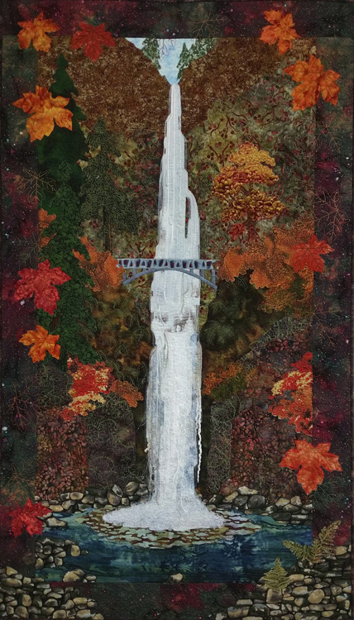
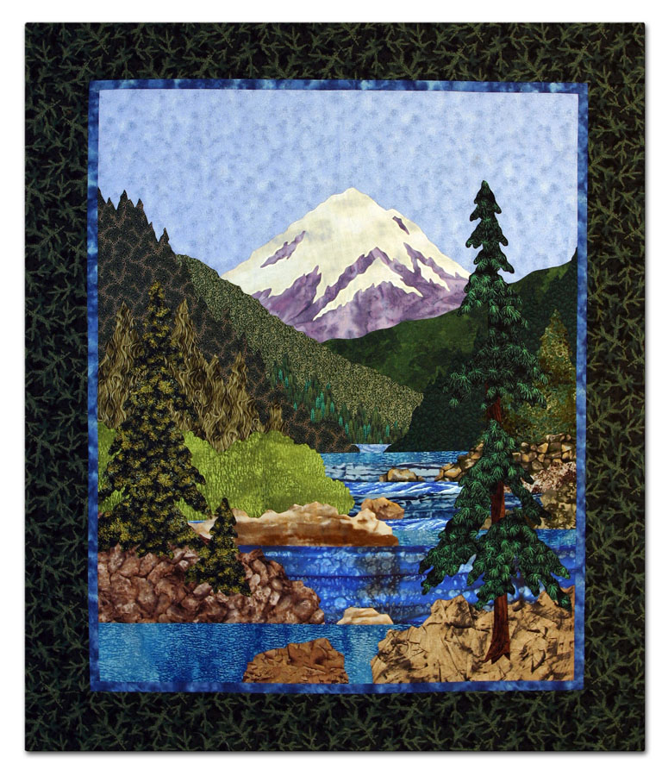
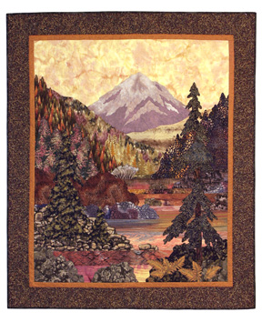
- Fusible web (optional): NOTE: this will not be used for the raw edged appliqué or hand appliqué but only for those wishing to construct their quilts using fused machine appliqué. How much is needed will depend on whether you mix techniques or rely mainly on fusing/machine appliqué. As some of the appliqué pieces are large, buying the adhesive in roll form is preferable to small packaged sheets. If you choose to use a fusible web, I strongly advise you to pre-wash your fabrics.
- Clear plastic sheeting (optional): For Multnomah Falls only! This material is sold by the yard at regular fabric stores and is intended to protect fancy tablecloths from spills. It can be used as a positioning guide by transferring the pattern onto the plastic with a ‘Sharpie’ brand marker then pinning it along the top edge over your work in progress and aligning your appliqué pieces under the plastic sheet. Hardware type plastic sheeting can be used as an alternative or another option is a clear plastic shower curtain. If you choose to use this method, buy a piece large enough to cover your entire appliqué.
- ‘Sharpie’ Brand Marking Pen: In black, to draw on the plastic sheeting if you are using an overlay. Get the fine point not the ultra-fine.
- Decorative embellishment yarns: These are great to use to embellish your waterfall. Choose eyelash yarn or yarns that have a frizzy and/or silky texture in white, off-white or light blues and grays. Having more than one will add extra dimension to your waterfall. A couple of yards of each should be plenty.

Mountain Stream
The amounts given are the minimum needed; get more if you plan on fussy-cutting any pieces. Colors are not specified on the legend; rather you should study landscape photography for color and texture references based on season or time of day.

* Indicates directional piece. Be sure your fabric print is oriented correctly for the piece(s).

FABRIC | NOTES
SKY*: ¾ - 1 yard | Use lesser amount for pattern running selvedge-to-selvedge, larger amount for pattern running parallel to selvedge
MOUNTAIN: fat quarter – ½ yard | A fat quarter is barely enough, ½ yard will provide more flexibility
SNOW: fat quarter
TREE RIDGES #1 & #2: ½ yard each of two fabrics | Choose fine textures that coordinate well with each other but have enough contrast for definition.
TREES #3 - #10: eight fat quarters | A variety of green or other season appropriate colored fabrics in textures ranging from fine for far trees to coarse textures for close.
BUSHES #1: fat quarter | Choose a shade or color that stands out from the other trees.
WATER STRIPS* #1 - #9: ¼ yard selvedge-to-selvedge cuts each of five to seven different fabrics | ¼ yard is for linear prints/pattern running selvedge-to-selvedge, if pattern runs parallel to selvedge use fat quarters and piece the strips or buy 1 yard cuts. Choose fabrics with a horizontal linear texture, some fabrics may be repeated. For best results, colors should transition from one to the next fairly smoothly
TREE TRUNK #10: 5” x 18”
ROCKS #1 - #10: five or more different fabrics 10” x 20” each | Prints/textures should range from medium to coarse. Fabrics with a random mottled or blotchy appearance are best.
Narrow Inner Border: 6” selvedge to selvedge cut | NOTE: this amount may increase if you customize your quilt as described on page 9 of the instructions
Wide Outer Border: 20” selvedge to selvedge cut | NOTE: this amount may increase if you customize your quilt as described on page 9 of the instructions

Multnomah Falls

The amounts given are the minimum needed; get more if you plan on fussy-cutting any pieces. Colors are not specified on the legend; rather you should study landscape photography for color and texture references based on season or time of day.

* Indicates directional piece. Be sure your fabric print is oriented correctly for the piece(s).

MUSLIN: 24" x 44" | CANYON:
SKY: 11"x 6" | C1* - 23"w x 13"h
TREES: | C2* - 24"w x 26"h
T1* – 10"w x 6"h | C3* - 24"w x 22"h
T2* - 8"w x 16"h | C4* - 20"x 20"
T3* - 7"w x 13"h | C5* - 15"w x 17"h
T4 – 8"x 10" | WATER:
T5 * - 8"w x 19"h | W1* - 6"w x 13"h
FOLIAGE: | W2 &W7 – 9"x 21" total
F1, F5 & F6 – 13"x 15" total | W3* - 24"w x 8"h
F2, F3 &F4 – 9"x 9" total | W4* – 16"w x 5"h
BRIDGE: | W5* - 11"w x 18"h
B1* - 12"w x 3"h | W6 & W8* -6"w x 18"h total
B2 – 11" x 6" | FERN SPRAY: (optional at bottom right) A piece large enough to fussy-cut a clump of ferns from a suitable print.
ROCKS:
R1 & R2* – 24"w x 13"h total
BORDERS: 20"x 45"

