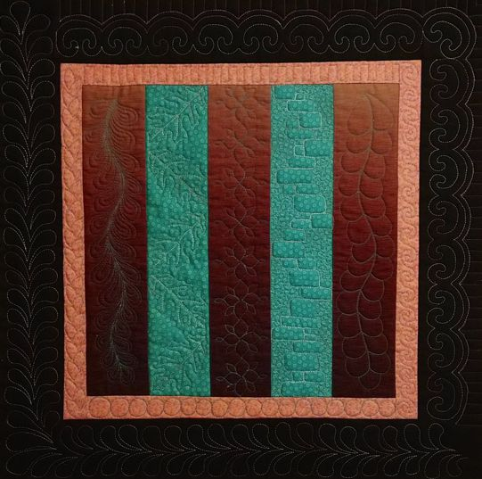
Borders! These can be a joy to stitch or a demon you wrestle with on every quilt (I fall into the latter category). Border designs are often uniquely different than the designs that get applied to other parts of a quilt and present distinct challenges such as how to plot them to fit or how to turn a corner… issues that you don’t need to tackle with quilting blocks and center panels on quilts. In this class, you will learn several techniques ranging from plotted to improvisational borders to add to your repertoire of quilting skills. Please be courteous to others by arriving for class with the correct supplies. Contact me at 503-631-8806 or helene.m.knott@gmail.com if you have any questions.

A Note to Students: Many students do not realize that once the teacher is paid, the shop offering a class makes little if any income on the class itself. The shop is relying on product sales to continue offering quality classes to you. Therefore, I urge you to patronize this shop when buying your supplies for this class as much as possible and remind you that big chain stores do not offer the variety of classes that the smaller shops do. Keep quilt classes alive by supporting this shop.
Thank you, Helene

TOOLS/MATERIALS:
- Pieced Sampler You will bring a pieced sampler based on the Amish Stripe pattern that will provide plenty of opportunities to try out various border treatments. The sampler will need to the layered with batting and backing and quilted in the ditch before coming to the class; instructions follow at the end of the supply list. NOTE: you may want to make more than one layered sampler to have a back-up to play with.
- Sewing Machine: A good basic home machine in good running condition, with feed dogs that can be dropped. A Singer Featherweight is not a good choice for machine quilting for a number of reasons. Please bring your owner’s manual if you have one and are not familiar with all the functions of your machine as well as the utility tools kit (small screwdrivers, brushes, etc) as you may need to perform some minor maintenance on your machine during class. Don’t forget your machine’s power cord and foot pedal!
- Sewing Machine Accessories: You need to bring a free motion or darning/embroidery foot for free motion quilting (this is absolutely necessary). Make sure you have the right foot! I have seen a number of students come in with an open-toed embroidery foot which is intended for zigzag stitching and will not work for free-motion quilting! You will also need a walking foot (this one is not absolutely crucial but will give you better results than trying to sew straight lines with a free motion foot). It’s also a good idea to fill and bring extra bobbins so you don’t have to interrupt your flow to wind bobbin thread.
- Sewing Machine Needles: Bring a package each of quilting and topstitching, needles in size 11 (or 12) and 14 suitable for your machine. Microtex ‘sharps’ in size 12 are optional but can be helpful.
- Stitching Test Square: This is simply a square about 14”x 14” of the same batting as your quilt, layered between two pieces of fabric. You will use this for practicing and to run a test for stitch length and tension before stitching on your quilt.
- Regular Straight Pins
- Thread: 100% cotton machine quilting thread in size #50 or #60. Do not use polyester or heavier (#40 or #30) thread. The amount of thread you will need will be dependent on the density of the particular patterns you choose for your quilting. I do recommend bringing a generous amount of thread though (two regular sized spools of each color should do). You will need thread that is just slightly a different color or shade to match your fabric (this one can be variegated if desired), and a thread in a contrasting color as well. A variety of colors will allow you to pick and choose ones suitable for the designs you want to use.
- Quilter’s marking pen: the blue (rinse-away) type.
- Chalk marking pencil: Choose a color that will show up against your fabrics
- Drawing pencil: with a good eraser.
- Utility Scissors and thread snips
- Seam Ripper
- 18” Ruler
- Paper: a few sheets of 8½” x 11” paper to do some practice drawings on.
- Machine Quilting Gloves or Finger Cots (Optional): Help you grip the quilt more effectively and give you greater control of your stitching. If you opt for gloves, avoid the bulky quilting gloves with the little rubber dots. Choose instead ‘Machingers’ or the yellow ones put out by Fons & Porter.
- Class handout packet: Included with class.

Machine Quilting Borders Practice Sampler

For the best results, choose fabrics that read as solids; you do not want a print or pattern that is so pronounced that it interferes with your ability to see and critique your stitching.

For the pieced sampler you will need:
Three 3½” x 15½” strips of Fabric A
Two 3½” x 15½” strips of Fabric B
Two 1½” x 15½” strips of Fabric C (narrow borders)
Two 1½” x 17½” strips of Fabric C (narrow borders)
Two 3½” x 17½” strips of Fabric D (wide borders)
Two 3½” x 23½” strips of Fabric D (wide borders)
One 26” square of thin even batting
One 28” square of backing fabric

Piece the 3½” x 15½” strips to each other alternating colors as shown below. Sew on the two shorter narrow border strips C to either side of the center followed by the two longer narrow borders C to top and bottom. Repeat this process with the wider outer border strips D. Press all seams to one side (this is important!). Layer and pin it with batting and backing, using safety pins spaced about 6” apart or spray baste if preferred, then quilt in the ditch along all seams

Due to limited time and table space and the size of the classroom, you will need to have your quilt layered and stitched in the ditch before coming to class. The following directions will help you do this properly.
Choose a fabric for your quilt back that is the same weight or slightly heavier than your top. This will make your back more stable than the top and reduce the puckers and tucks that can occur on the backside of the quilt while you are machine quilting. Iron the top and the back before layering to remove any wrinkles or creases. Secure the back (wrong side up) to a work surface such as a table or floor with tape or clamps stretching the back just enough to ensure it lies flat and even without overstretching it. When the quilt back is secured, spread the batting over the back and smooth it out carefully. Do not stretch it artificially tight or it may contract after your quilt is pinned and create puckers in your quilting. After the batting is in place, position the top (right side up) in the center of the batting. Smooth it out carefully as you did with the batting and start pinning the top in a grid pattern with safety pins spacing them about 5”-6” apart in each direction. Don't forget to pin the edges too. If you have an excessive amount of batting and backing extending beyond the edges of your top, trim it down to a couple of inches; ideally, you want your backing and batting to be just a little larger than your top so that you don't run out of backing as you approach the edges of your top. Note: If layering on a table that is not big enough to secure the entire quilt at once, you may work on sections at a time, securing, layering and pinning one area before shifting and securing the next area. Take extra care when shifting and securing if working in sections as there is a greater chance of developing slackness in the quilt back during these shifts and you must be careful to secure the next area with as much consistency as the first. If you prefer to use a basting spray in lieu of pinning that is fine but remember that basting adhesives will gum up your needles faster than regular pinning.
After layering and pinning, stitch all the seams in the ditch. If desired, you can also run a machine basting stitch around the outer perimeter of the quilt but remember to use the longest stitch on your machine as this stitching will be temporary.

