Quiltworx – One (from the Leaf Series) Wall Hanging or Table Runner
August 22, 2026 10am-4pm, Montavilla – PDX Store (on Stark St)
This is a foundation paper piecing project to help introduce students to Quiltworx patterns and processes. It makes a stunning 20”X40” quilt that can be displayed on the wall or as a table runner. The pattern is one of a few in the Leaf Series, called One. In the class you will learn basics of Quiltworx pattern reading and techniques that give you perfect placement of the fabrics including sharp points, curved piecing and a little bit of applique.
Preparing for class – Carolyn is offering a pre-class workshop on July 25th from 1:30-4:30pm at the Portland Montavilla Store (on Stark St) where she can assist students with fabric and color selection as well as show students how to prepare the papers prior to class. So that when class arrives, the students are ready to do final cutting and sewing. She will demonstrate three techniques in class – foundation paper-piecing, curved piecing and applique. Quiltworx makes these typically challenging techniques simple and easy to accomplish in their step-by-step instructions for beautiful results.
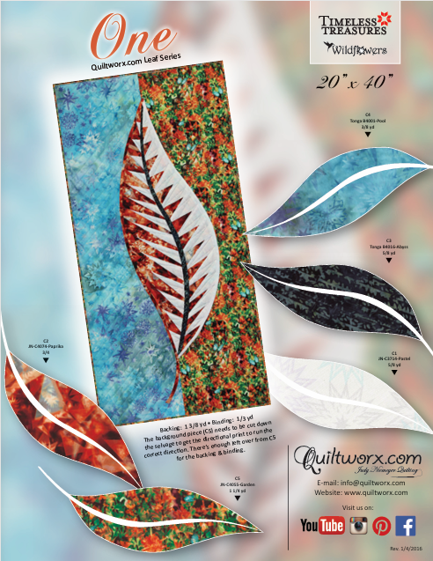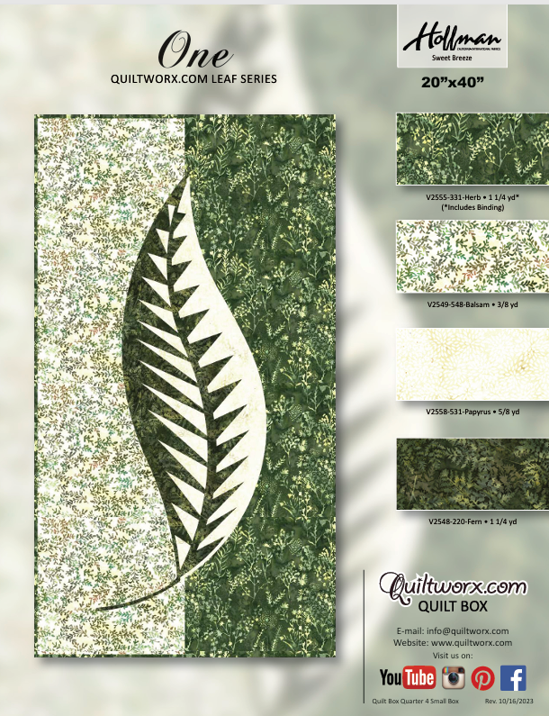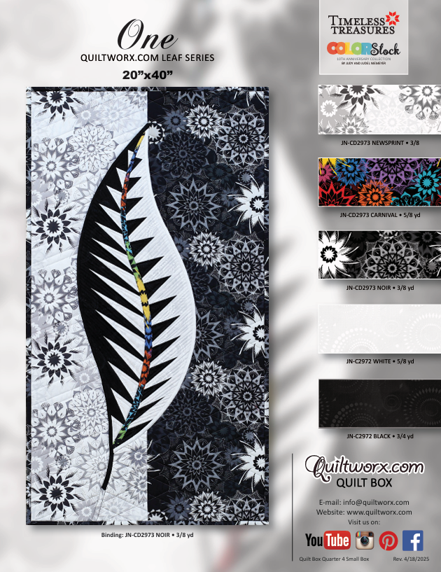
Fabric Yardage Required*:
- Fabric #C1 – 5/8 yard for light portion of leaf
  - Cut 22-1/2” WOF (width of fabric)
- Fabric #C2 – 3/4 yard for dark portion of leaf
  - Cut 9X33 rectangle
- Fabric #C3 – 5/8 yard for leaf vein
  - Cut 22-1/2” WOF
- Fabric #C4 – 3/8 for half of light background
  - Cut 13-1/2” WOF
- Fabric #C5 – 3/8 for half of dark background
  - Cut 13-1/2 WOF
- 1-3/8 yard backing & batting
- 3/8 yard for binding
* more yardage may be needed for directional fabric
Other Supplies Needed:
- Rotary Cutter
- 6-1/2 x 24” ruler for cutting width of fabric
- Add-A-Quarter Ruler – 12” or 18”
- Sewline Fabric Glue Pen plus refills on hand
- Scotch Repositionable Craft Stick* – blue label, white clue inside
- Elmers Washable School Glue* – orange label, purple glue inside
- Roxanne’s Basting Glue (optional)
- Size 70 Microtex sewing needles for piecing, Size 60 needles for applique
- Matching thread for piecing and quilting – 50-60 wt (you can applique with this thread also)
- 80-100 wt thread for applique (silk thread works great) (optional)
- Turning Template to use with the Add-A-Quarter ruler – I will provide students with this if students do not have one.
- Three gallon Ziploc bags to organize pieces
- Large paper clips
- Light pad (optional)
- Good operating sewing machine capable of straight and zigzag stitch
- Typical sewing tools such as awl or stiletto, seam ripper, tweezers, pins, clips, etc.

* I will have a limited supply on hand
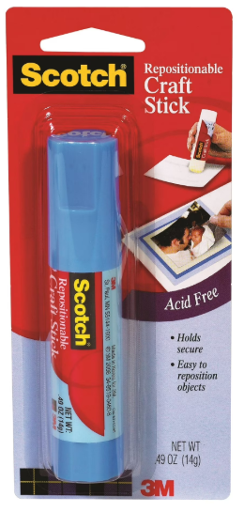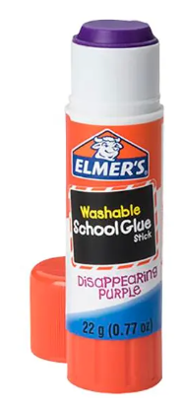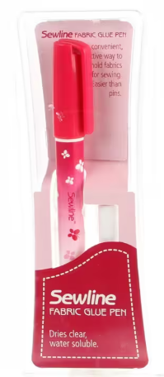
Pre-Class Instructions –
Students are welcome to swing by the Portland Montavilla on Saturday July 25th, from 1:30-4:30 to get help with cutting and/or fabric selection.
- Cut fabrics in accordance with the cutting instructions (see notes above in fabric section)
- Trim all templates and units on newspaper sheets included in the pattern
  - Trim all templates on the outside solid line (do not cut apart template layout sheets (TLS))
  - Cut all T-templates on the solid outside line
  - Cut all Units 1/8th to 1/4th of an inch outside the solid black line

Templates/Units:
- Units – what you sew fabrics onto – creates finished blocks/units to be sewn together in the assembly process
- Template – used to cut individual pieces to be sewn into blocks used in the foundation paper-piecing process
- Template Layout Sheet – combines many templates into once rectangle or shape for ease of cutting individual pieces
- T-Template – a piece of fabric sewn only during the assembly process, not used in the foundation paper-piecing process

