These flowers are bold, colorful, and textural—reminiscent of Mexican fiesta paper flowers. As they are made up of multiple layers, the process involves raw edged machine appliqué as opposed to fusing which would make the quilt or garment incredibly stiff and hard to stitch through. If desired, embellishments such as beads, fringe and/or lace can be included for added texture. The flowers can be composed on a simple pre-quilted background panel or made freestanding to apply to a garment or bag.

Please be courteous to others by arriving for class with the correct supplies. Contact me at 503-631-8806 or helene.m.knott@gmail.com if you have any questions.

TOOLS/MATERIALS:
- A 10” x 12” (or larger) pre-quilted or stabilized ‘background’ panel: A top, batting and backing, layered and quilted. This need not be fancy quilting – a rough all-over stippling or pebbled texture will be sufficient. Alternatively, you can also just iron on an embroidery stabilizer to the back of the panel. The fabric for the panel should contrast with the fabrics you choose for the flowers; an abstract print that is quirky and fun could be a great choice as long as it doesn’t compete with the flowers you will create. NOTE: you could also apply this method to embellish a garment such as a vest or jacket if you wish.
- A variety of fabric pieces or scraps in sizes ranging from 2” to 8”: You will need at least 5 or more fabrics for each flower in lots of colors ranging from light to dark. Bright saturated colors would be best but you can choose any colors you wish. You can also add stems or a trailing vine; bring yarn, ribbon, or cord for these if you wish.
- Scissors: A pair of fine-bladed craft scissors for cutting fabric, and larger heavy utility shears for paper.
- Freezer Paper: a couple of 8 ½” x 11” sheets or an 18” square from a roll.
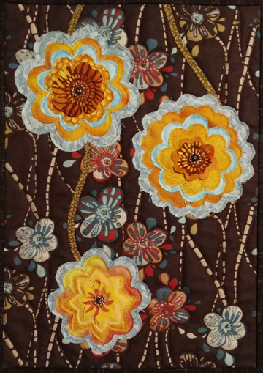
- Sewing thread: The thread can match your fabric or contrast with it. Thread can be cotton, rayon or metallic (if you feel comfortable sewing with it).
- Sewing Machine: With free motion capabilities as well as some interesting embroidery stitches (optional). Bring the appropriate presser feet for both functions.
- Sewing machine needles: Even though you won’t be fusing, you will be stitching through many layers of fabric so good strong sharp needles are a must. Micro-tex needles in size 12 and/or top stitching needles (12 and/or 14) would be best.
- Embellishments: Beads or sequins would be great and so would rick rack trim and decorator fringe (the type you might buy for pillows or upholstery in the home decorator section of a fabric store). Lace would be great too but make sure it’s not too wide and preferably the type that is slightly ruffled.
- Beading or strong polyester thread: only needed if you are using beads for embellishments.

