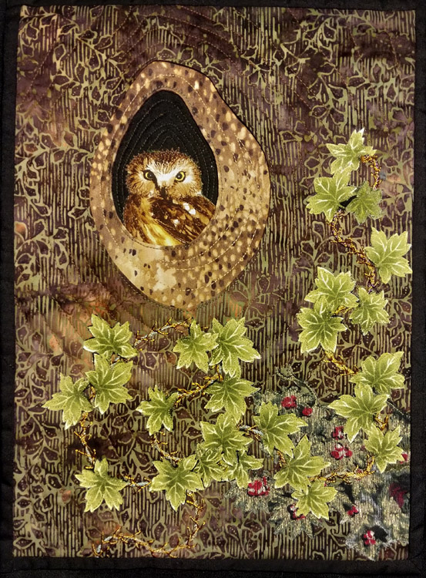
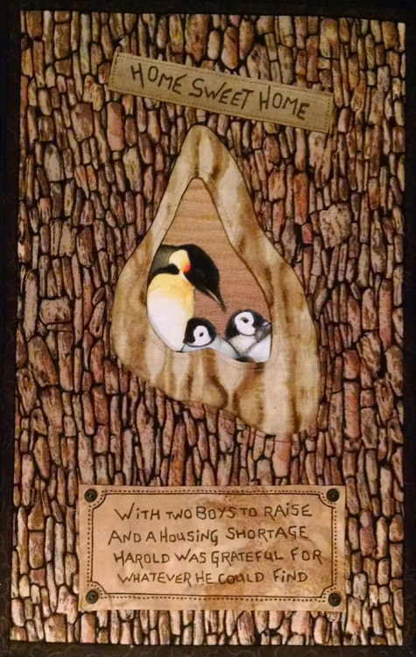
“My home is a hole in a tree”. There are a number of creatures who can make this claim – owls, parrots, some birds, bees, squirrel, raccoon… Our Art Quilt Technique project this month will be to ‘build’ a three dimensional hole in a tree using a method of faced applique, and then choosing an animal to reside in it. You can go for a ‘natural’ animal in its habitat or go for whimsy and a laugh with an improbable creature.

Please be courteous to others by arriving for class with the correct supplies. Contact me at 503-631-8806 or kittystomp@comcast.net if you have any questions.

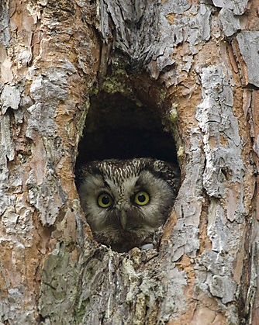
A Note to Students: Many students do not realize that once the teacher is paid, the shop offering a class makes little if any income on the class itself. The shop is relying on product sales to continue offering quality classes to you. Therefore, I urge you to patronize this shop when buying your supplies for this class as much as possible and remind you that big chain stores do not offer the variety of classes that the smaller shops do. Keep quilt classes alive by supporting this shop. Thank you, Helene

TOOLS/MATERIALS:
- Tracing Paper: Preferably Golden Threads Quilting Paper™
- Pencil and a good eraser
- Fabric Backing: This can be any size you wish b I suggest about 9” x 12”
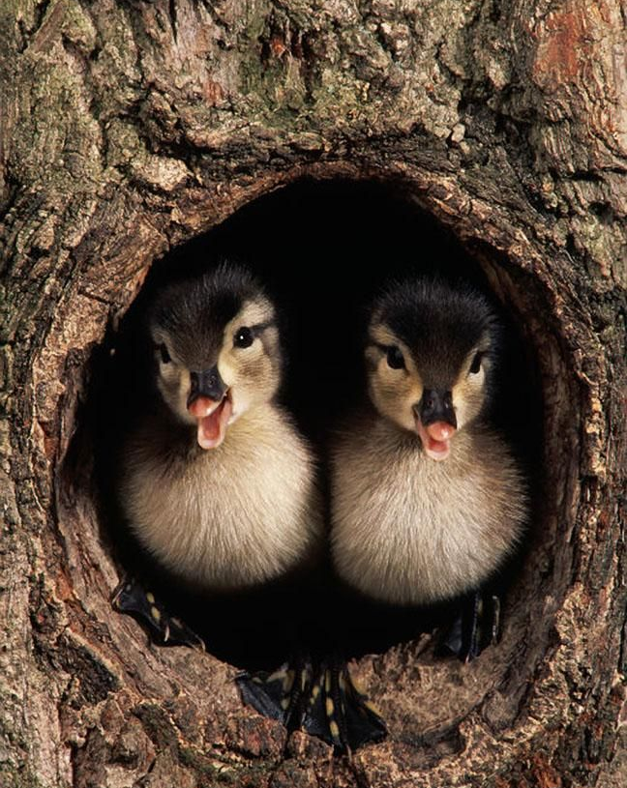
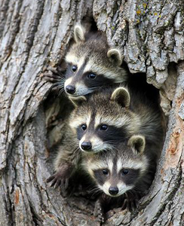
- Fabrics: You will need two to three fabrics that are appropriately textured to represent tree bark; these should coordinate well with each other but with enough contrast to make them interesting. You also need to choose an animal print, this can be any animal suggested in the overview above. You could of course go for whimsy and choose something wildly inappropriate like a moose or dinosaur peering out from your tree hollow; but it’s important that the size of the animal print be appropriate for the size of the hollow you make. You can adjust the size of your hollow to fit the animal but you still need to make sure it’s not too large or too small; I recommend a motif somewhere in the range of 3” – 5”. Depending on the patterning and layout of your animal print, you may also need a plain textured fabric in a very dark color like dark brown or black, if the animal print is a busy collage of lot of animals or on a light colored ground, you will need to fussy cut the individual animal out from the fabric and fuse it to the dark fabric for the best effect.
- Fusible Web: a sheet sized piece should do, I prefer something designated as ‘lite’ to make stitching through it easier.
- Batting and Backing: Bring a piece of thin even batting the same size as you plan on making your quilt, the backing should be slightly larger..
- Thread: In a colors that coordinate with your bark fabrics and the animal print
- Sewing Machine: Preferably with a free-motion foot; you can use a standard presser foot for this but it will make it a more labor intensive process, free motion stitching is much faster (and you don’t need to be particularly good at it for this).
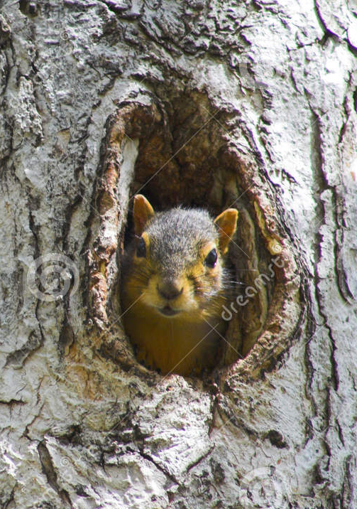
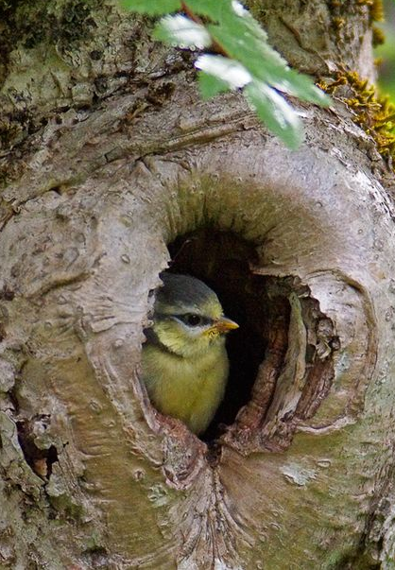
- Scissors: A pair with fine, sharp blades that can handle small detailsSeam Ripper: always good to have one handy.
- Pattern: You can Google “Animals That Nest in Tree Holes Images” to see examples of the various creatures and the holes they live in. I will provide a template you can use as well but it may not fit your chosen critter.

