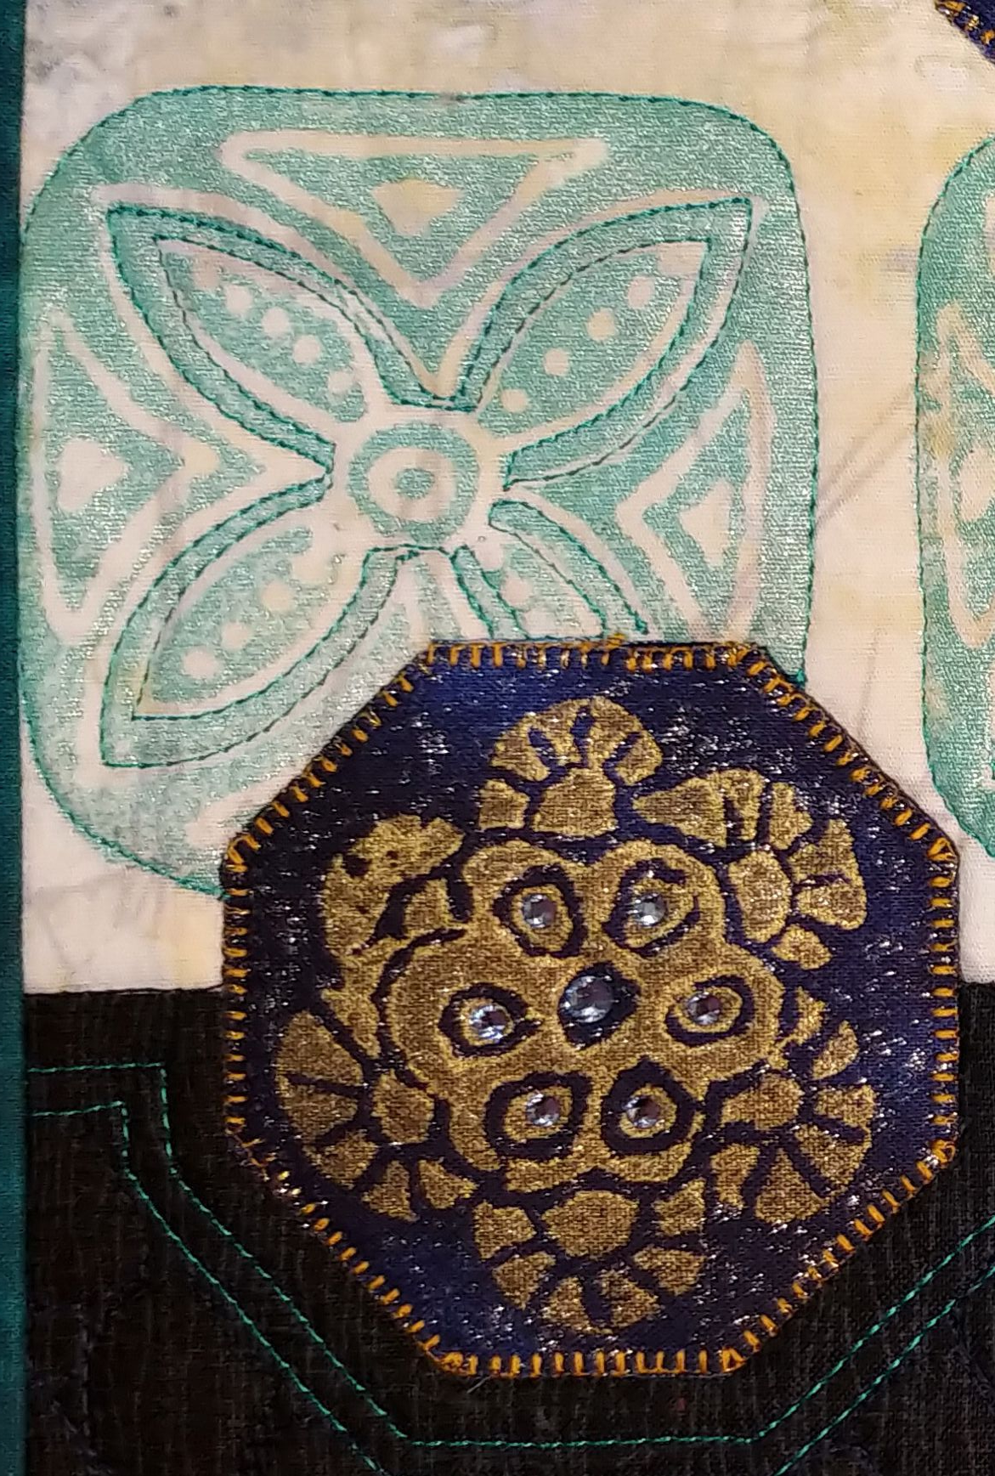
These fabric stamps are truly ‘green’ as they are made from recycled Styrofoam that would otherwise end up in a landfill. They are inexpensive, easy to make, and give results that look as beautiful as more elaborate carved rubber or wood stamps – without the carving. There is no carving involved, if you can trace a design, you can make these stamps. Once made, the stamps can be used on fabric or paper. Wear old clothes in case you get paint on them, textile and acrylic paints are permanent.
Please be courteous to others by arriving for class with the correct supplies. Contact me at 503-631-8806 or helene.m.knott@gmail.com if you have any questions.

TOOLS/MATERIALS:

- Ball point pen: This will be used both for tracing the pattern onto the foam and also to ‘carve’ it.
- Drawing pencil and a good eraser
- Utility scissors: These will be used to cut out the finished stamp after it has been carved
- Masking Tape: 1” – 2” wide.
- Fabrics: Fabrics that read as a solid are the best choice, they need not be 100% cotton, even exotic materials -silk, leather or suede-cloth, are fun to play with. I recommend the pieces be large enough (9” x 12” or slightly larger) that you could turn the entire piece into a small Art Quilt if you so choose. For the clearest prints a smooth surfaced fabric (like Batik) is best. You could also bring a scarf or T-Shirt to stamp on.
- Cushioned stamping board* (see note below)
- Plastic or Styrofoam picnic plate: to use as a palette.
- Styrofoam meat trays: Clean and with smooth, not ridged or textured surfaces. I will have some to share if you don’t have your own.
- Plastic gloves: optional but will help keep paint off your fingers.
- Paints: I will bring a variety of acrylic and textile paints for students to use.
- Brown paper or plastic ‘grocery’ bag: personal trash bag for the paint covered paper towels.
- Design Sources: These can be designs you found on the internet or from an artist/craftsman source book like Dover clip art books. For manageable stamps look for designs that are simple in outline shape (line-work designs inside the outer shape are fine), primitive and tribal designs are great for this or you can go for abstract. Keep the overall stamp design between 2”-3”. I will have some source books you can trace designs from.

NOTE*: To get good clear impressions from your stamps, you need a lightly padded board with a smooth surface, similar to a padded ironing board. We will NOT use the shop’s ironing board for this. You can make one by wrapping a piece of thin cotton batting over a piece of cardboard/foam core board (or an old discarded cutting mat) then wrapping a piece of smooth muslin over that; the ideal surface is something firm with a very thin padding that isn’t too puffy. Alternatively, you could use a folded old pillowcase. Use something you don’t mind ruining as it will get paint on it. I will have some padded boards students can use but will need them returned at the end of the class.

